**Machine Learning Theory (CS351) Report**

**Discovering event episodes from sequences of online news articles: A time adjoining frequent itemset-based clustering method**

## 

## **Team Members:**

**1.** Mayur Bhat(181CO132)

**2.** Sukruth N Bhat(181CO154)

1. **INTRODUCTION**

Environmental Surveillance is conducted by an organization in the business environment to identify important events concerning customers, competitors, industry, technology, broad economic conditions, and government policies and regulations. Information gained from this kind of surveillance helps in strategy formulations, decision making, and business actions which is crucial to their performance and competitiveness. In this paper focus is online news articles. Online news articles have become an integral part of environmental surveillance because of unprecedented growth of the internet. Companies use Event evolution patterns (EEPs) in order to perform environmental surveillance. EEPs actually show the evolution of a particular event type over time which helps them to get prepared for similar events in the near future. EEPs do this by discovering from sequences of news articles (or documents) a common evolution pattern for distinct events of the same type. Focus is given for temporal relationships as well. There are several different event structures or taxonomies discussed in this paper.

Some of them are :

1. Story→Event→Topic
2. Story→Simple Event→Complex Event
3. Story→Component Event→Event
4. Story→Episode→Event.

In this project, Story→Episode→Event structure has been followed.

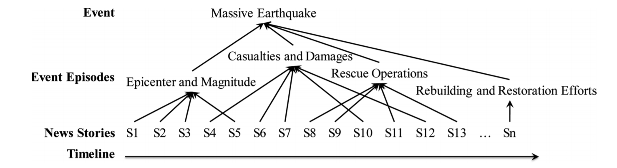

Fig1:- Example for the Story→Episode→Event structure

This image explains the Earthquake event. The initial episode may focus on the date and time, location, and magnitude of the quake; subsequent episodes could relate to casualties and damages, rescue operations, logistic support and survivor placement, and rebuilding and restoration efforts. These news articles sometimes might have similar content but their themes will differ noticeably thereby they represent different episodes of the same event. Before performing EEP,identifying and grouping articles which represent distinct episodes of an event from a sequence of news articles (documents) that pertain to that event is needed. The traditional, manual approach to event episode discovery is ineffective and infeasible. There are two approaches mentioned in this paper for doing the same. They are retrospective event detection and event episode discovery.

1. **Retrospective Event Detection and Event Episode Discovery.**

Retrospective event detection techniques generally discover events from a stream of news articles. Basically it identifies events from a stream of articles by segmenting the different events described by these articles. Event episode discovery focuses on how an event evolves through different development stages and identifying news articles that pertain to each stage. Let’s consider a collection of articles about pandemics in the 21st century. If Retrospective event detection is used it may reveal distinct events i.e. Covid 19, Ebola outbreak in Africa and such other events and find news articles associated with each event. But with event episode discovery we will be able to identify the different development stages of these events over time i.e. if different stages of development of covid 19 is considered as the event then it will be identified by episodes such as initial breakout of Covid 19 in china, development of vaccines for covid 19 will be the episodes of covid19 and find news articles pertinent to each stage.

Overall, event episode discovery identifies distinct episodes of an event from a sequence of news articles pertinent to that event, whereas retrospective event detection identifies events from a stream of articles by segmenting the different events described by these articles. As a result, event episode discovery tends to perform analyses at a finer-grained level than retrospective event detection. The above reasons make event episode discovery more suitable for discovering event episodes from sequences of online news articles.

1. **Frequent itemset-based hierarchical clustering**

In FIHC, the documents are called transactions and the features of a document are called items. Items with a document frequency greater than the prespecified minimum (gf) threshold are identified as frequent features (items) which become the cluster centroids. These items are also called cluster labels. A document dj based of its own frequent items is initially assigned a set of candidate clusters. The most appropriate cluster for the document are determined according to the goodness of fit which is measured by a variable score.The score for a doc dj in the cluster cx is calculated by using the formula shown below

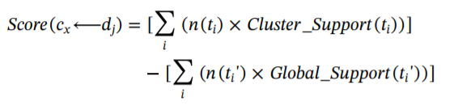

Here ti represents a global frequent item in document dj and is also a frequent item in cluster cx, ti’ denotes a global frequent item in dj but not a frequent item in cx, n(ti) indicates the weight of ti in dj, n(ti’) is the weight of ti’ in dj, Cluster_Support(ti) reveals the percentage of the documents in cx that contain ti, and Global_Support(ti’) depicts the percentage of the entire documents that contain ti’.

1. **Time-Adjoining Frequent Itemset-based Event-Episode Discovery (TAFIED) method**

TAFIED groups news articles by using both frequent items as cluster centroids as well as the temporal adjacency of documents in a cluster to ensure goodness of fit between a cluster and a document. In addition to steps mentioned in FHIC the adjacency of the respective time stamps of different news articles that belong to the same cluster (event episode) is property weighted. Thus, TAFIED can create clusters in which documents are temporally adjacent and share features that frequently appear in a stream of news articles. The overall processing of this method consists of document preprocessing, cluster initialization, cluster distinction, and cluster adjustment.

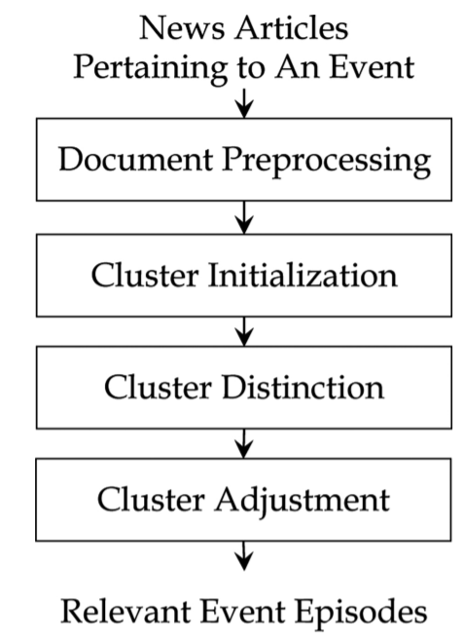

Fig2:- Steps in the TAFIED method

* 1. **Document Preprocessing**

In **document preprocessing,** meaningful terms like nouns, noun phrases, and verbs from each news article are extracted and a parser to select nouns, noun phrases, and verbs from the article is also used. Stop words such as non semantic-bearing words are also removed, and the remaining words are stemmed into their respective original forms. Basically the document is made ready for future steps.

* 1. **Cluster Initialization**

In **cluster initialization**, TAFIED constructs a set of initial clusters and assigns each news article to candidate clusters according to its own frequent items. Frequent items (terms) are first identified from the entire corpus of news articles under analysis. The process is similar to FIHC Term ti is a frequent item if the ratio between its document frequency (number of news articles with term ti) and the total number of news articles exceeds the prespecified minimum global support gt. By viewing each frequent item as a class label, our method can create a set of initial clusters. News articles then get assigned to candidate clusters on the basis of its own frequent items (class labels). We may have as many clusters as the number of frequent items identified, and a news article can be labeled as a member of multiple clusters.

* 1. **Cluster Distinction**

After cluster initialization, each news document will have at least one candidate cluster. Each news article should belong to one and only one event episode so **cluster distinction** has to be done. During this process, TAFIED assesses the fit between a document and each candidate cluster, selects the most appropriate cluster, and generates a final set of clusters. A fitness function is used for this purpose



Likelihood that a document dj belongs to a cluster cx a fitness function has been defined by this function. The main idea behind this function was that a news article describing a specific event episode should share features of high appearance frequency and temporal adjacency with articles about that same episode, compared with articles pertaining to another episode.

T is a set of frequent items, ti denotes a frequent item, CS(ti, cx) is the cluster support calculated as the percentage of documents in cx that contain ti, α is a parameter to control the impact direction of ti, TFIDF(ti, dj) represents the within-document term frequency × inverted document frequency for ti appearing in dj, and TP(cx) is a temporal proximity (TP) function for measuring the temporal adjacency of documents when dj is assigned to cx.

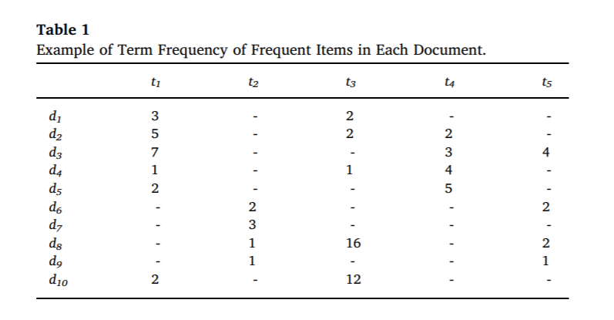

Fig 3 : Table showing term frequency of frequent items in each document.

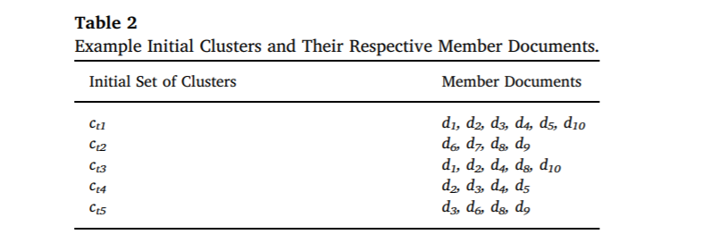

Fig 4 : Table showing the documents in each cluster.

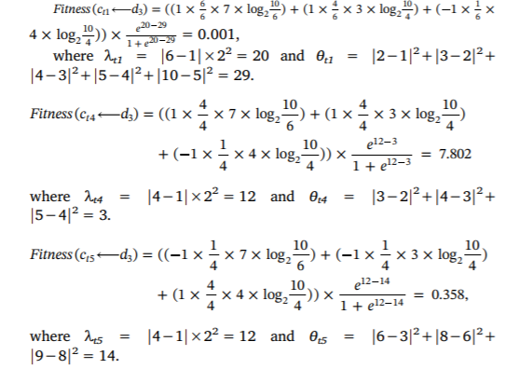

Fig 5 : Example calculation of fitness of document 3 in cluster 1, 4 and 5 respectively.

The fitness scores of d3 with respect to candidate clusters 1, 4 and 5 thus are 0.001, 7.802, and 0.358, respectively. Thus, document d3 is assigned to cluster 4.

* 1. **Cluster Adjustment**

Sometimes the use of frequent items as the base to cluster articles could lead to news articles that describe the same event episode scattered across multiple clusters after cluster distinction. As a remedy, we assess the need to merge two clusters in the **cluster adjustment** step. To perform cluster adjustment, TAFIED merges the clusters that contain highly similar or relevant documents. A combined cohesion measure evaluates the appropriateness of merging two clusters.

Event episode discovery should properly consider two issues: news articles describing different episodes of a particular event have similar content, and different episodes could emerge concurrently within a time window. TAFIED satisfies both the above requirements as it basically extends FHIC by incorporating temporal locality, according to the fit between a cluster and a document.

1. **IMPLEMENTATION**
   1. **Dataset Generation**

Python code

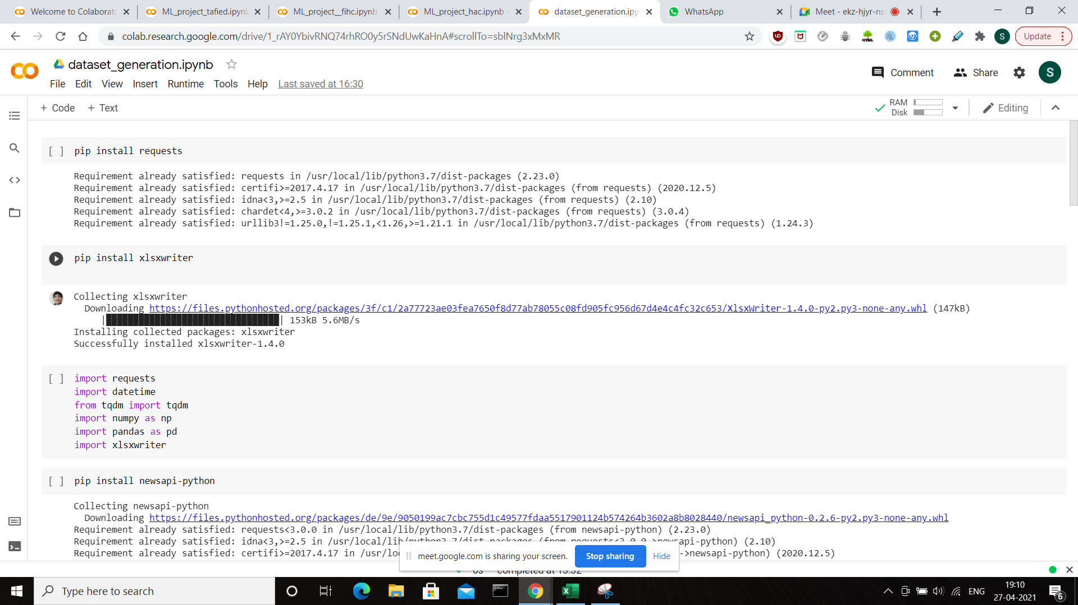

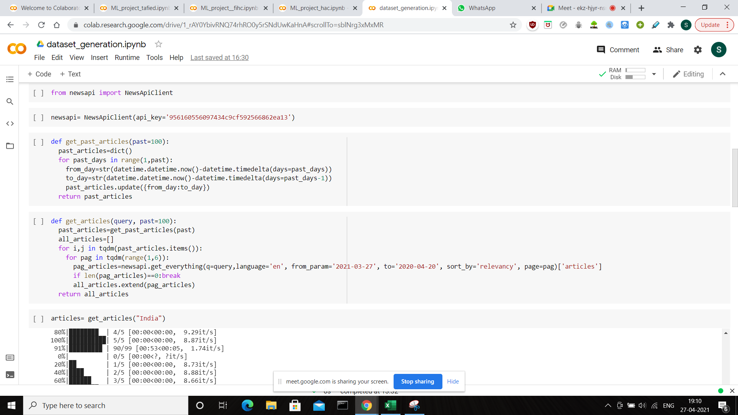

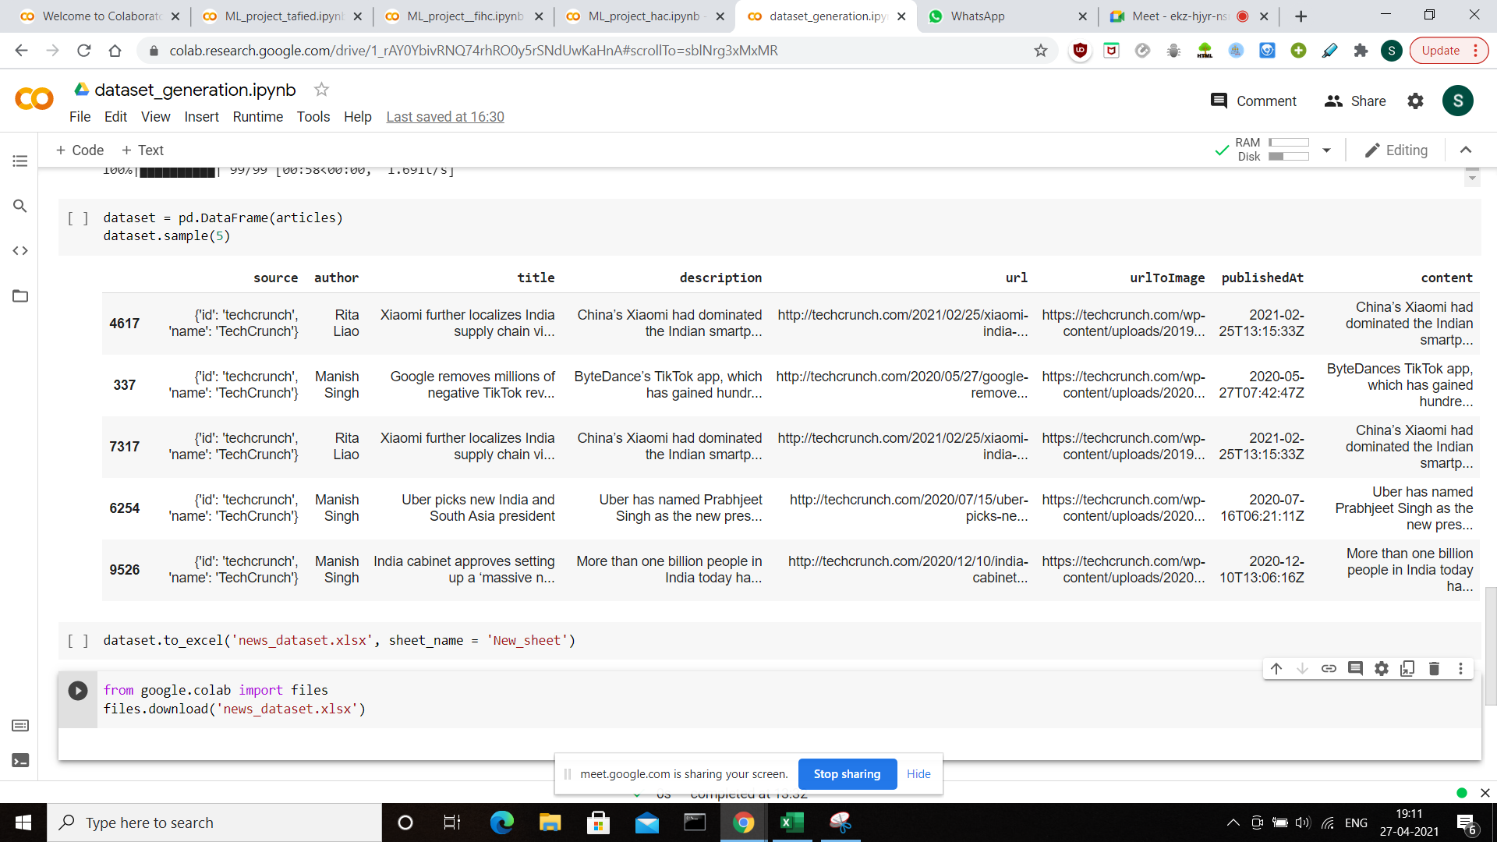

Output Dataset

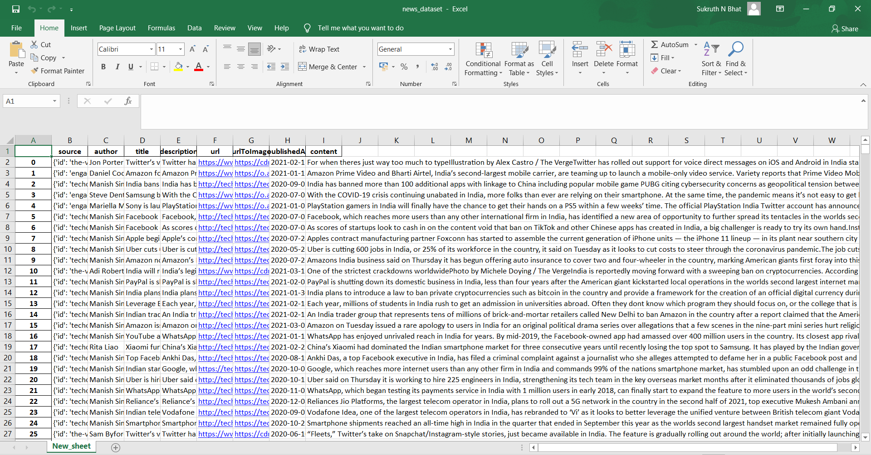

* 1. **Python TAFIED implementation**

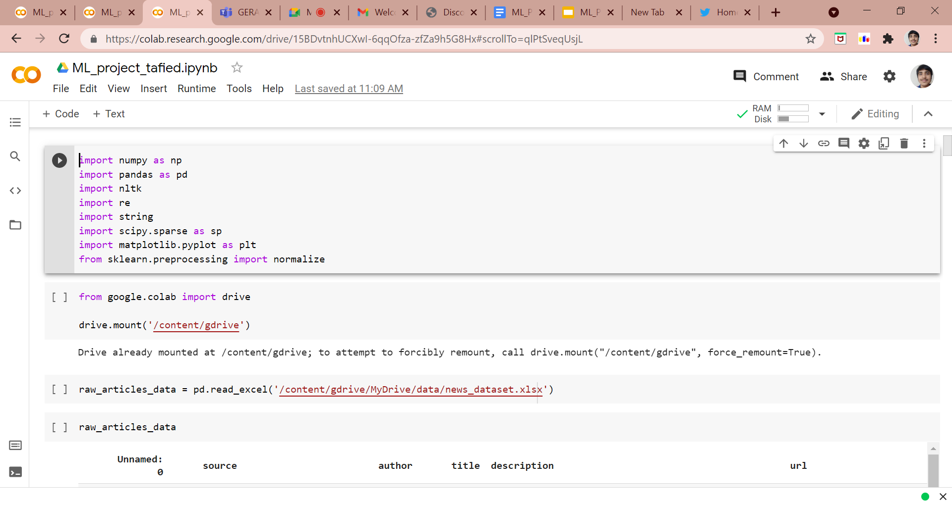

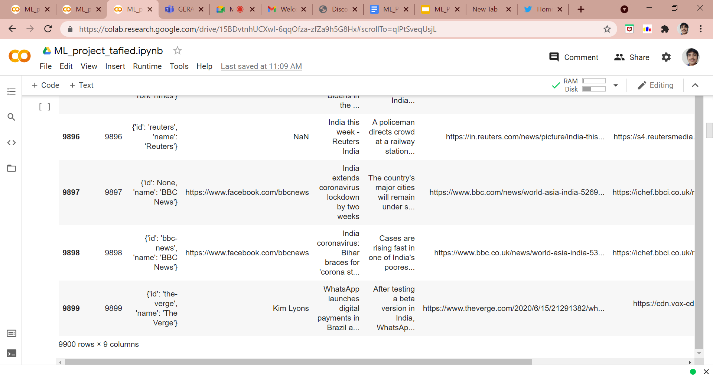

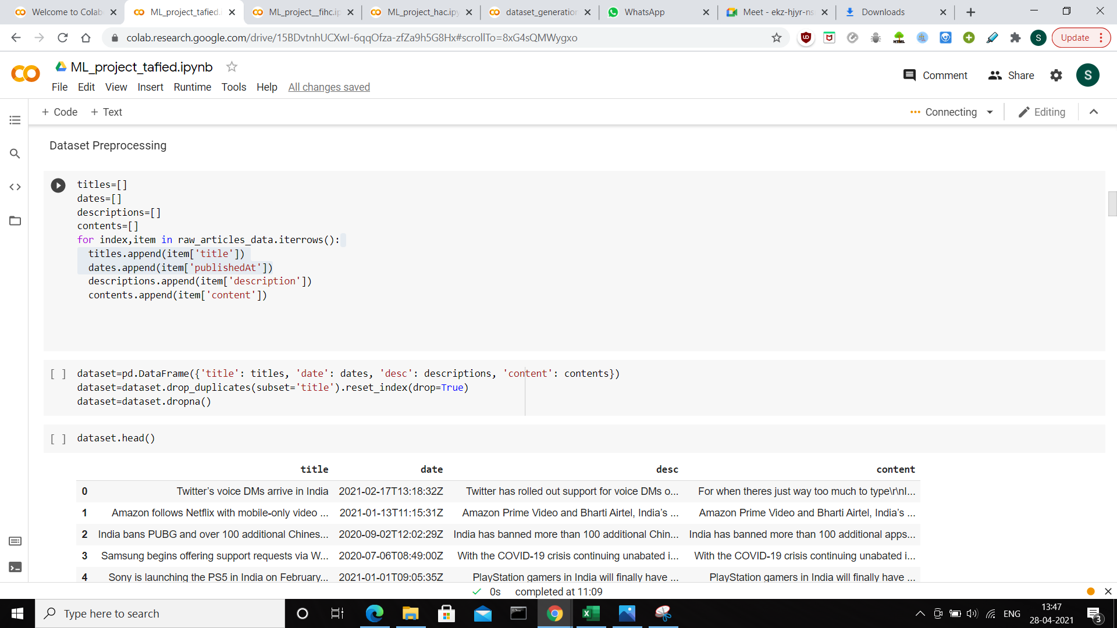

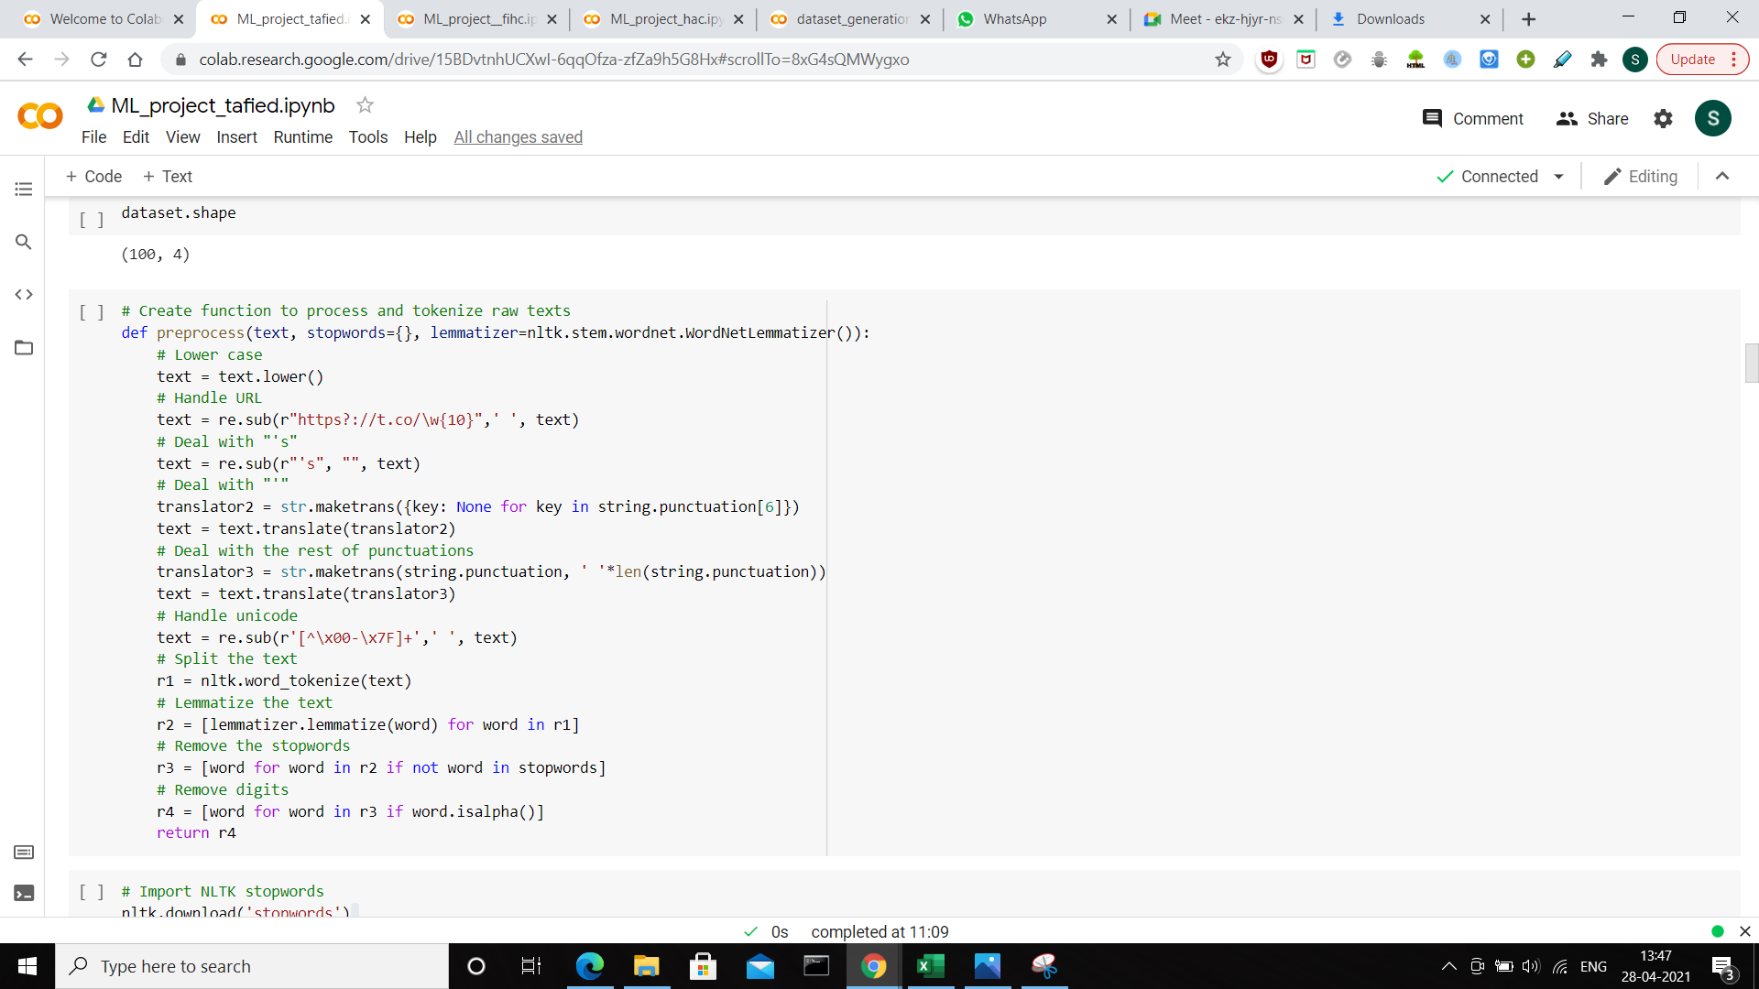

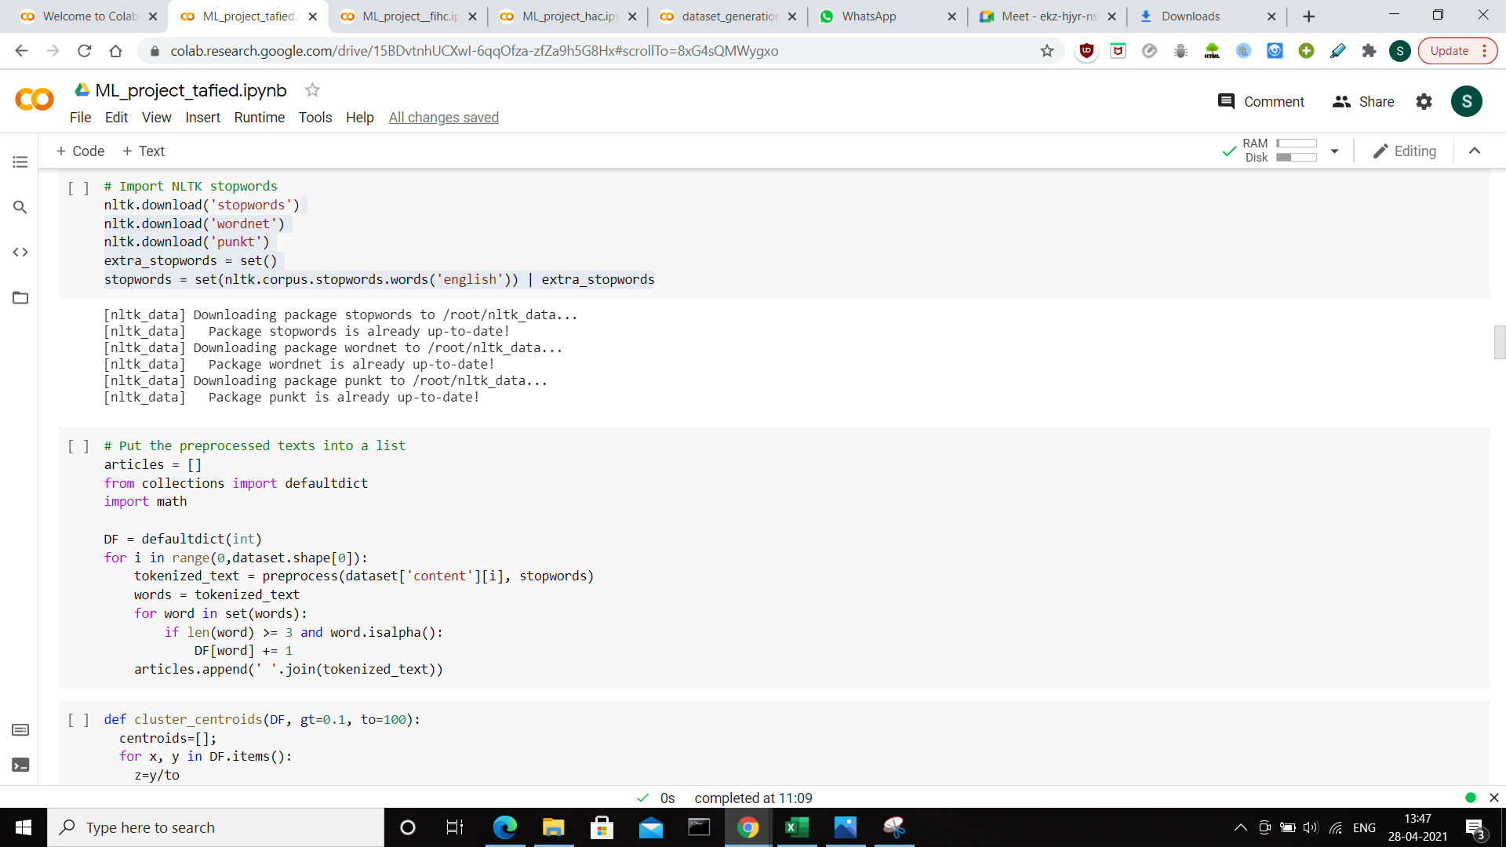

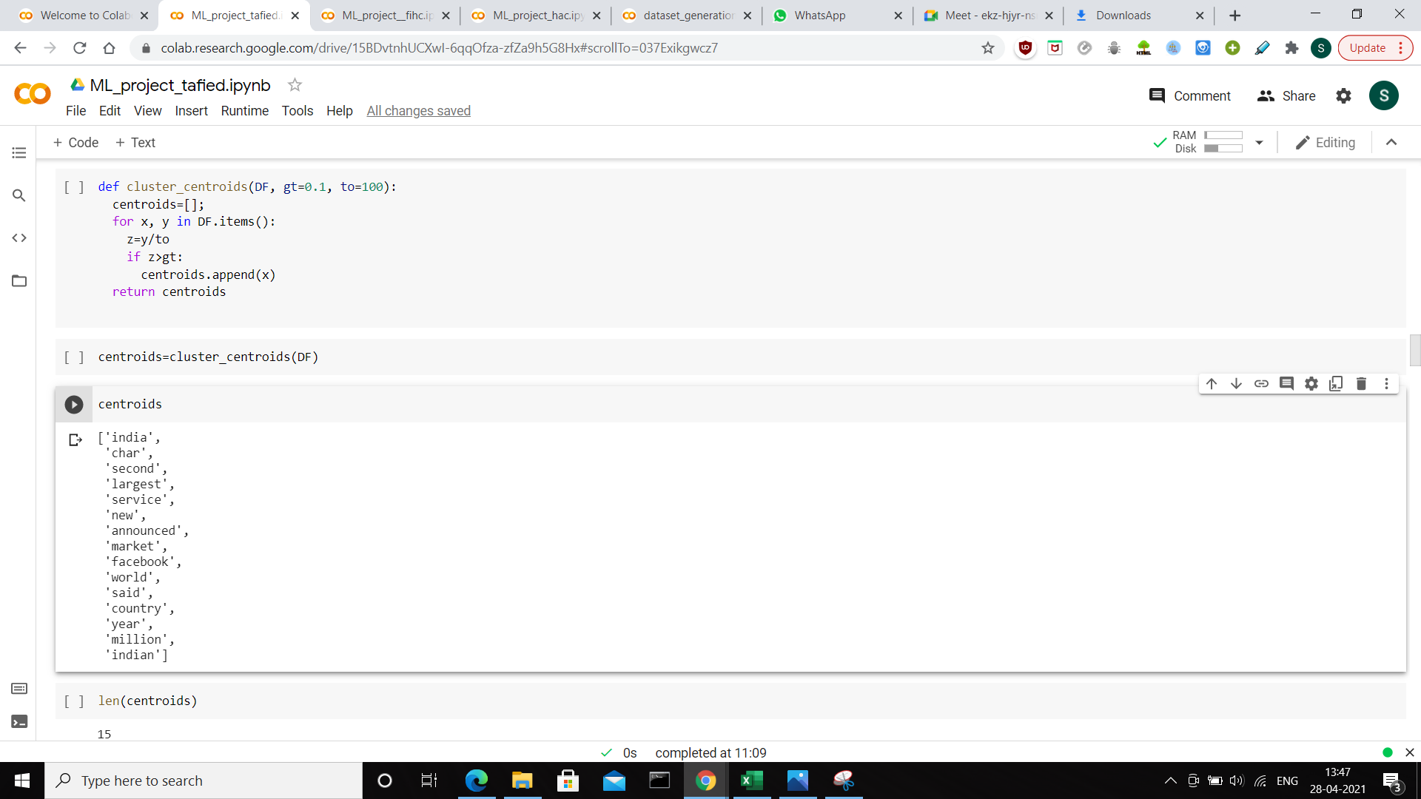

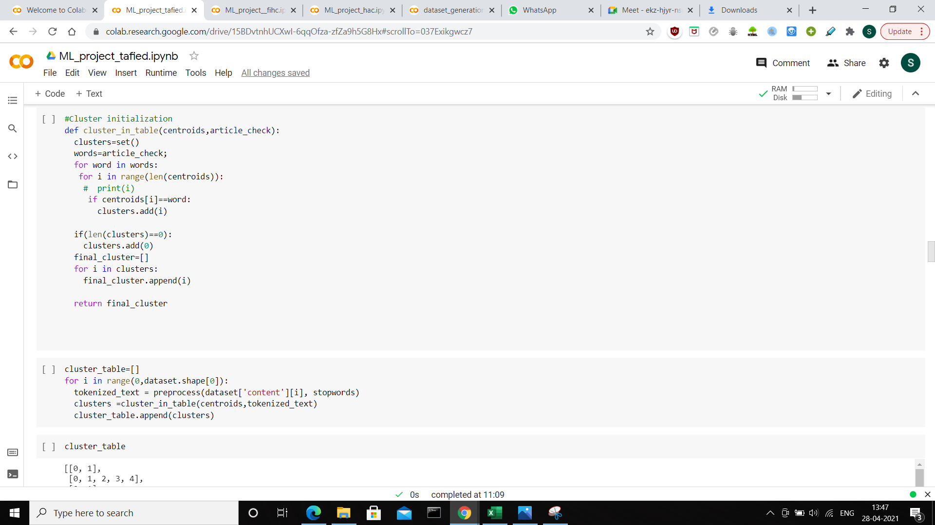

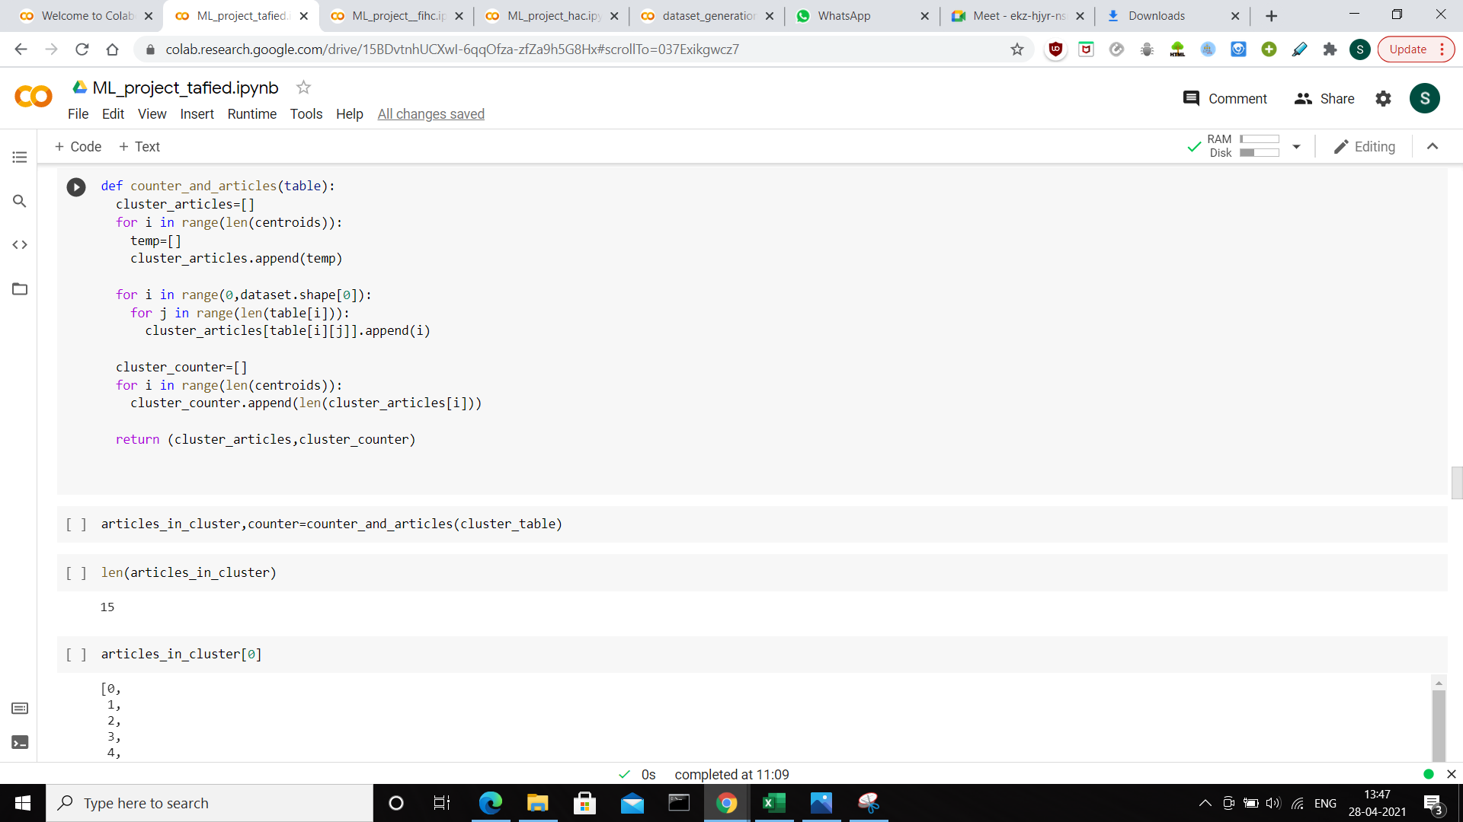

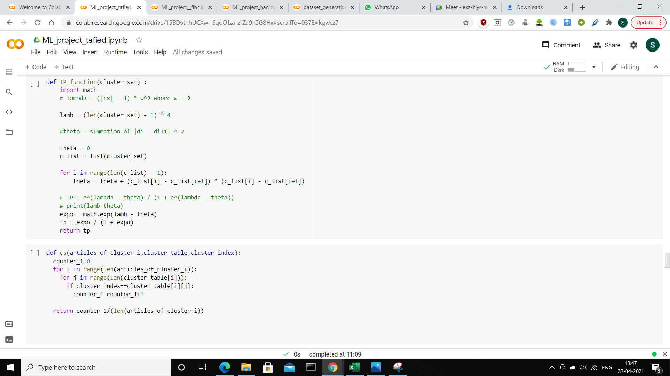

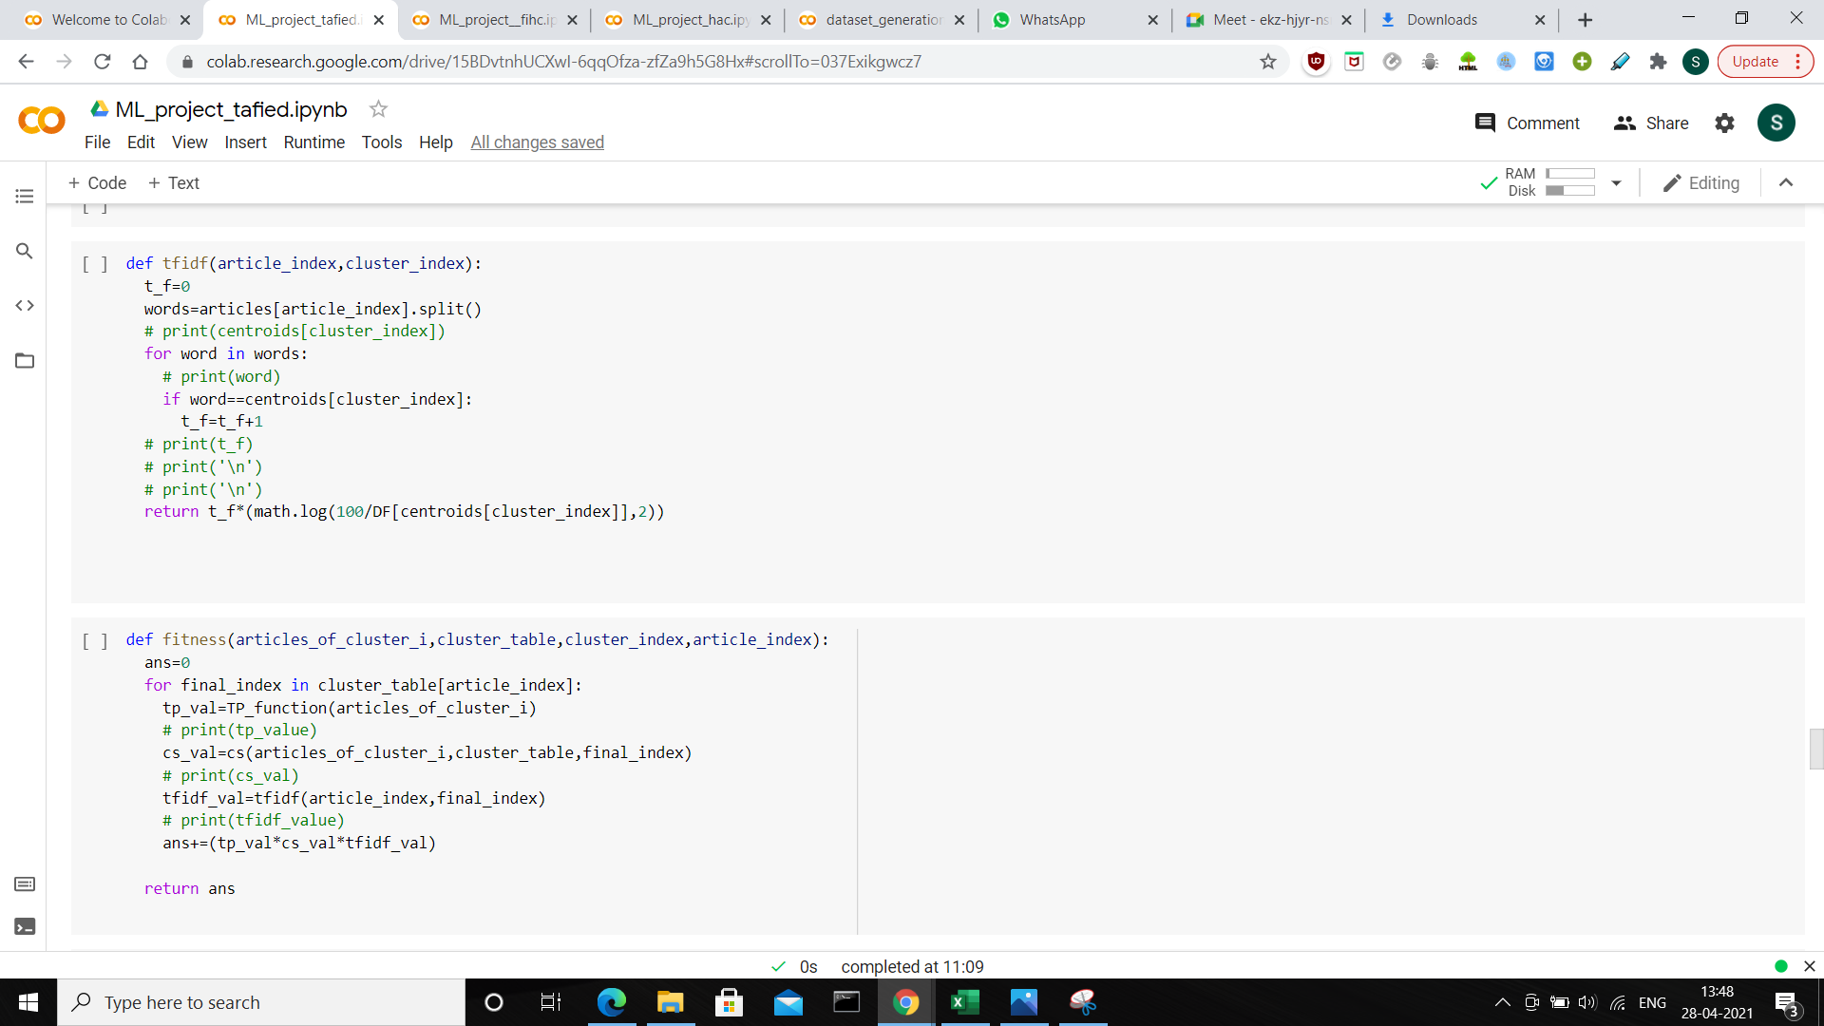

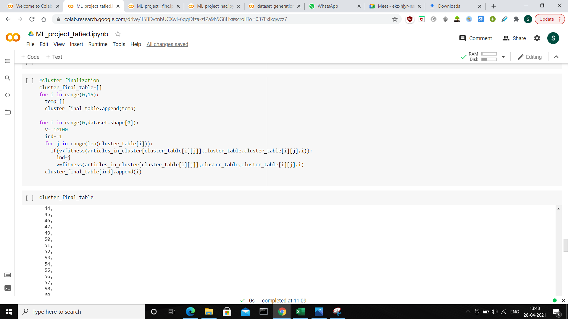

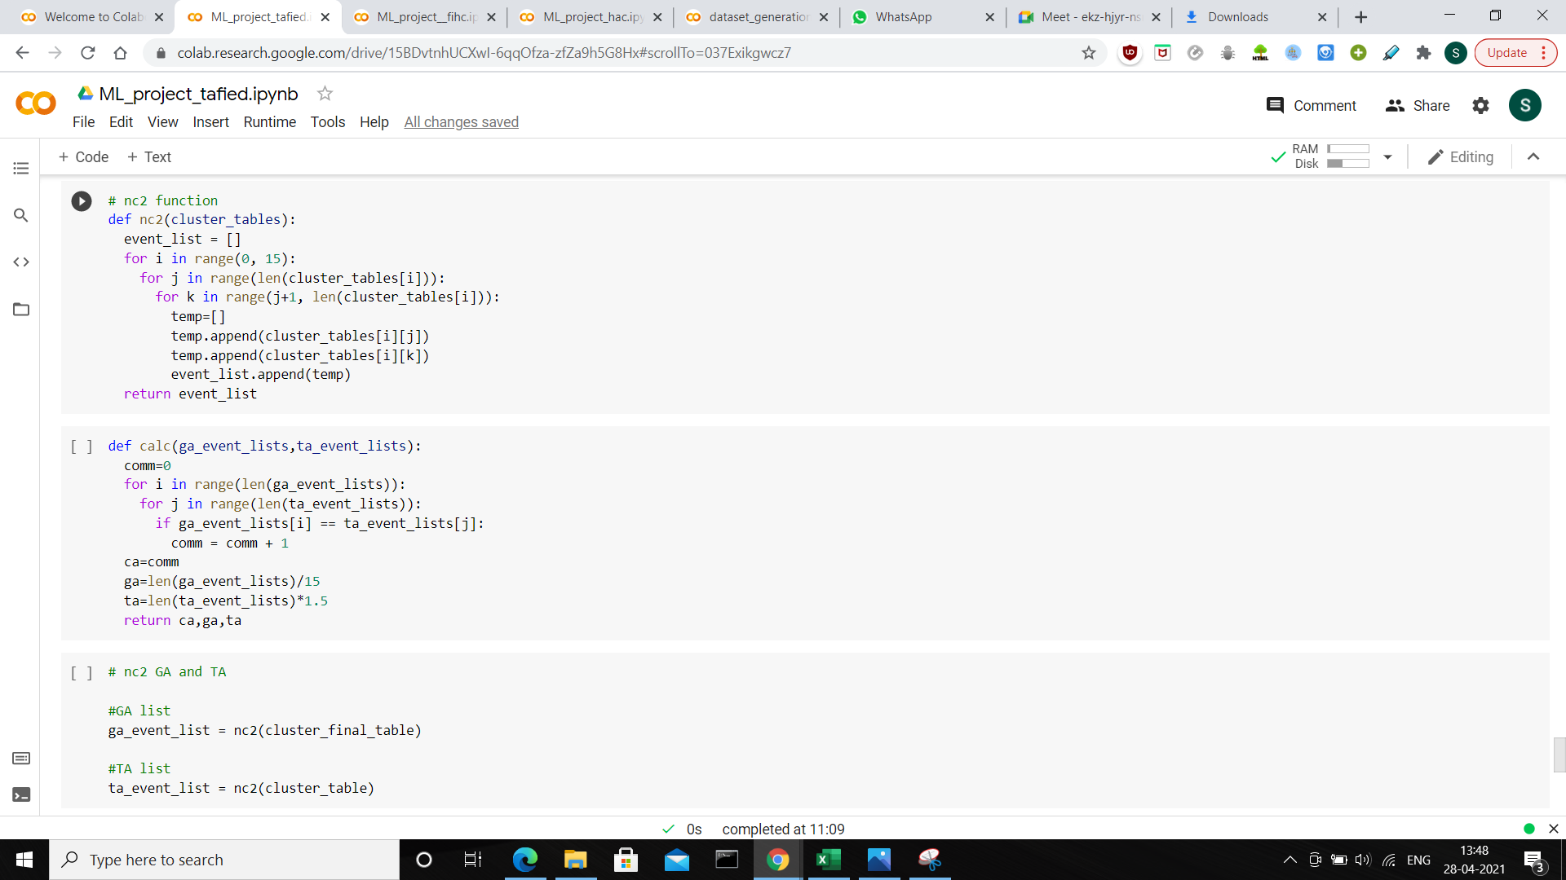

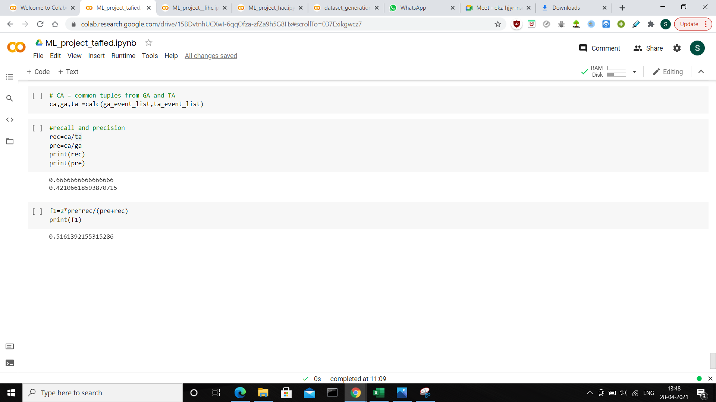

* 1. **Python FIHC implementation**

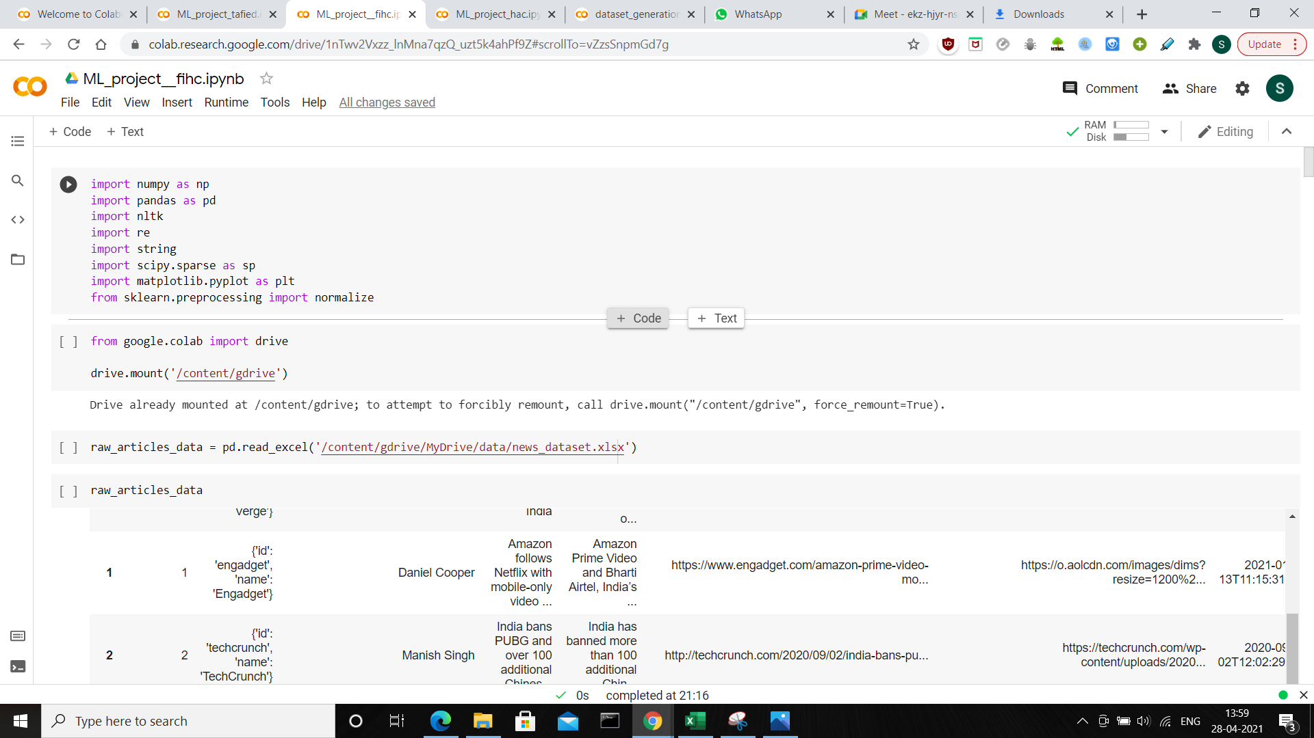

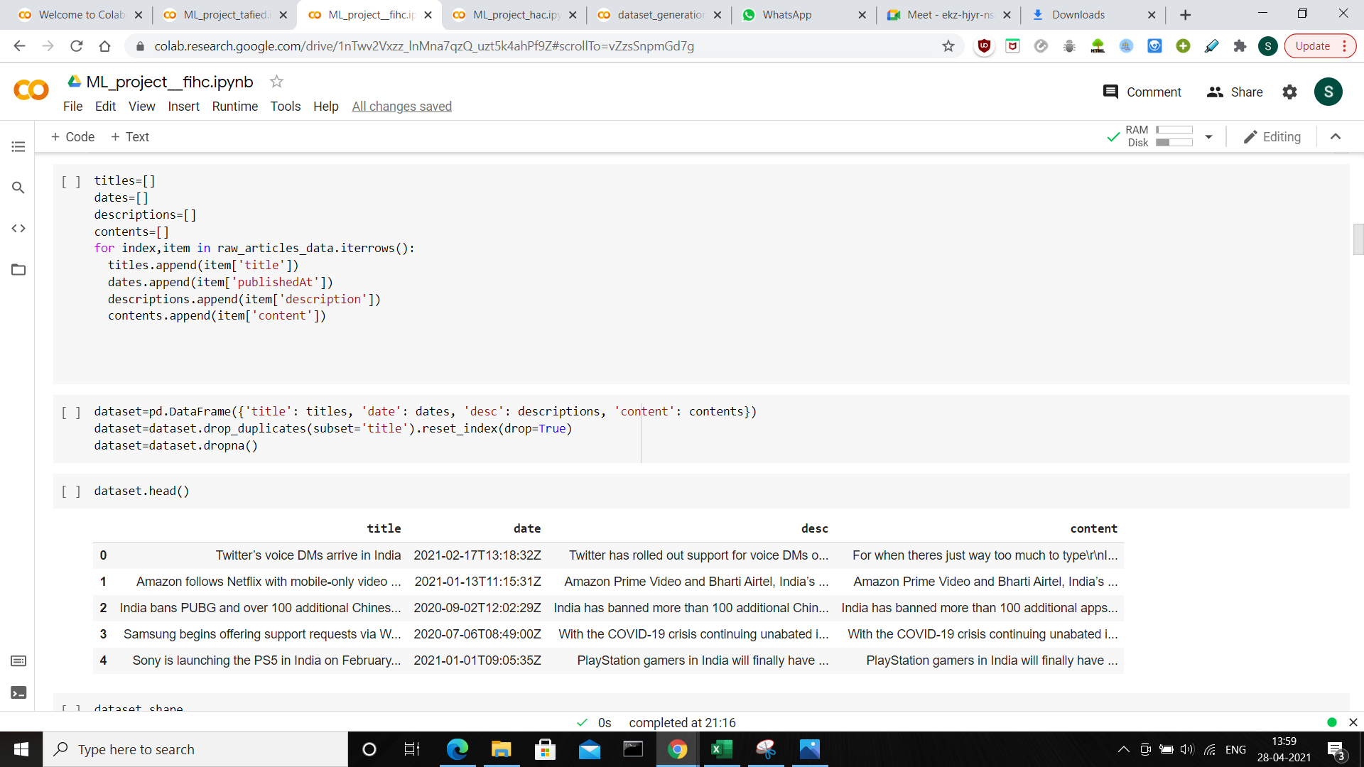

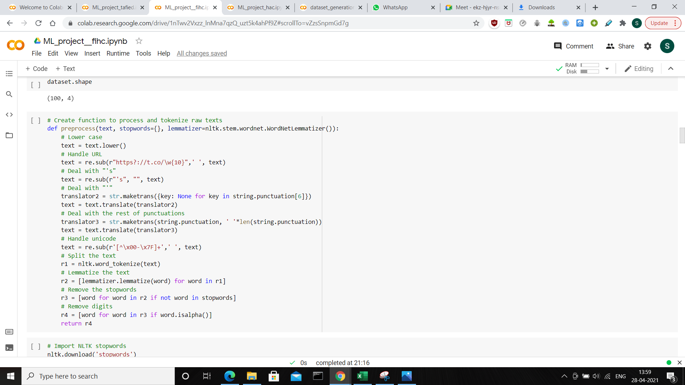

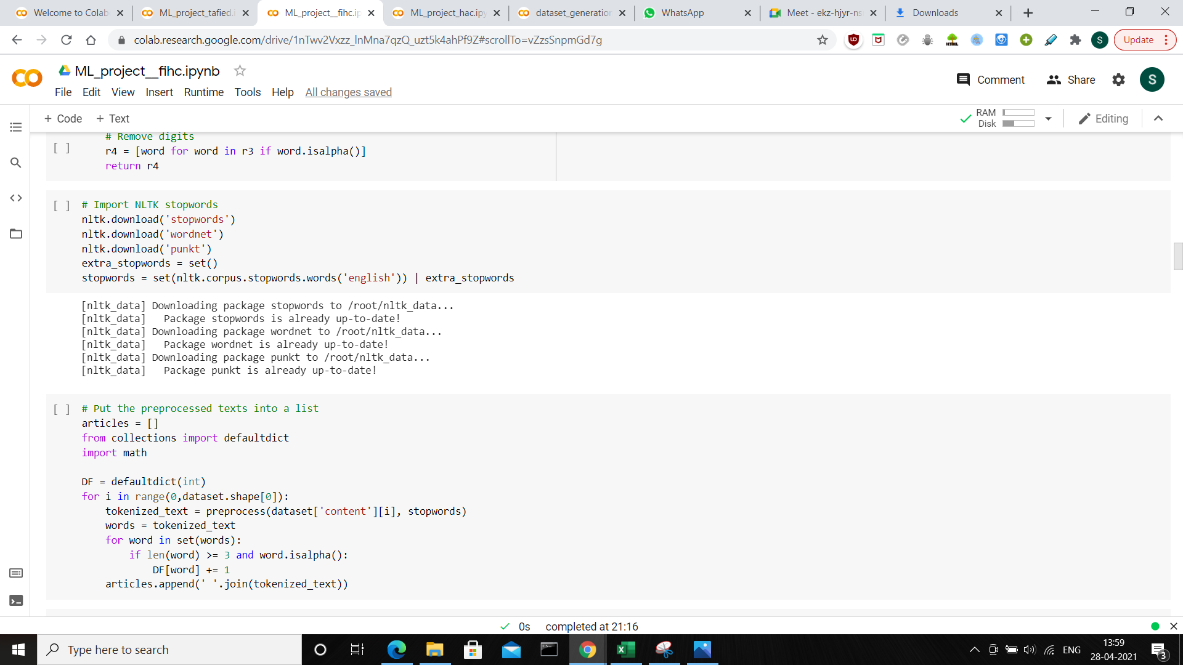

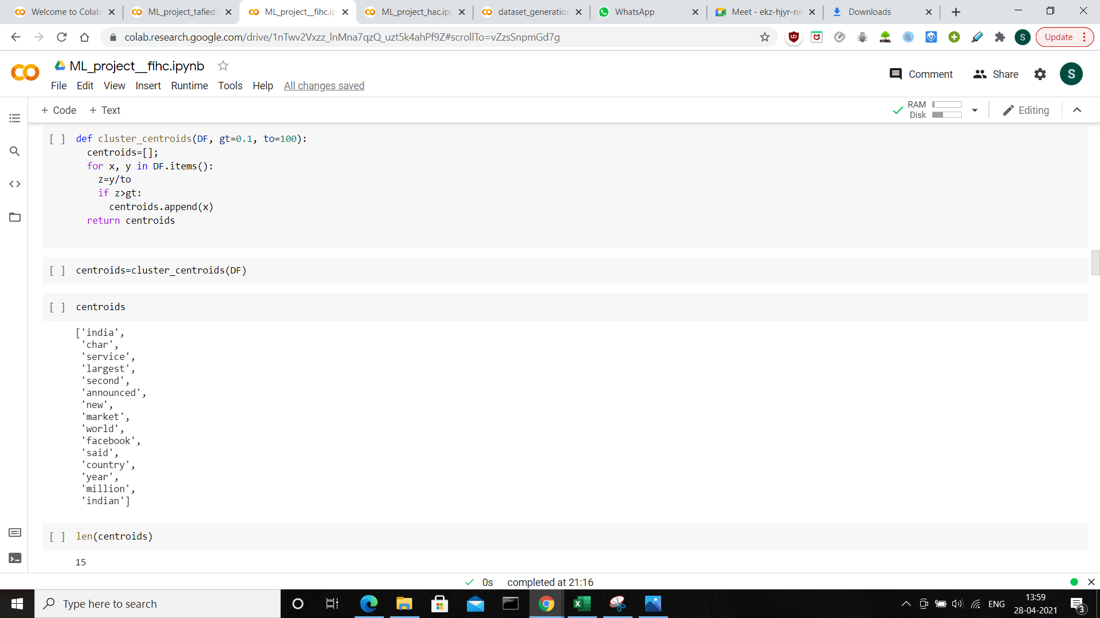

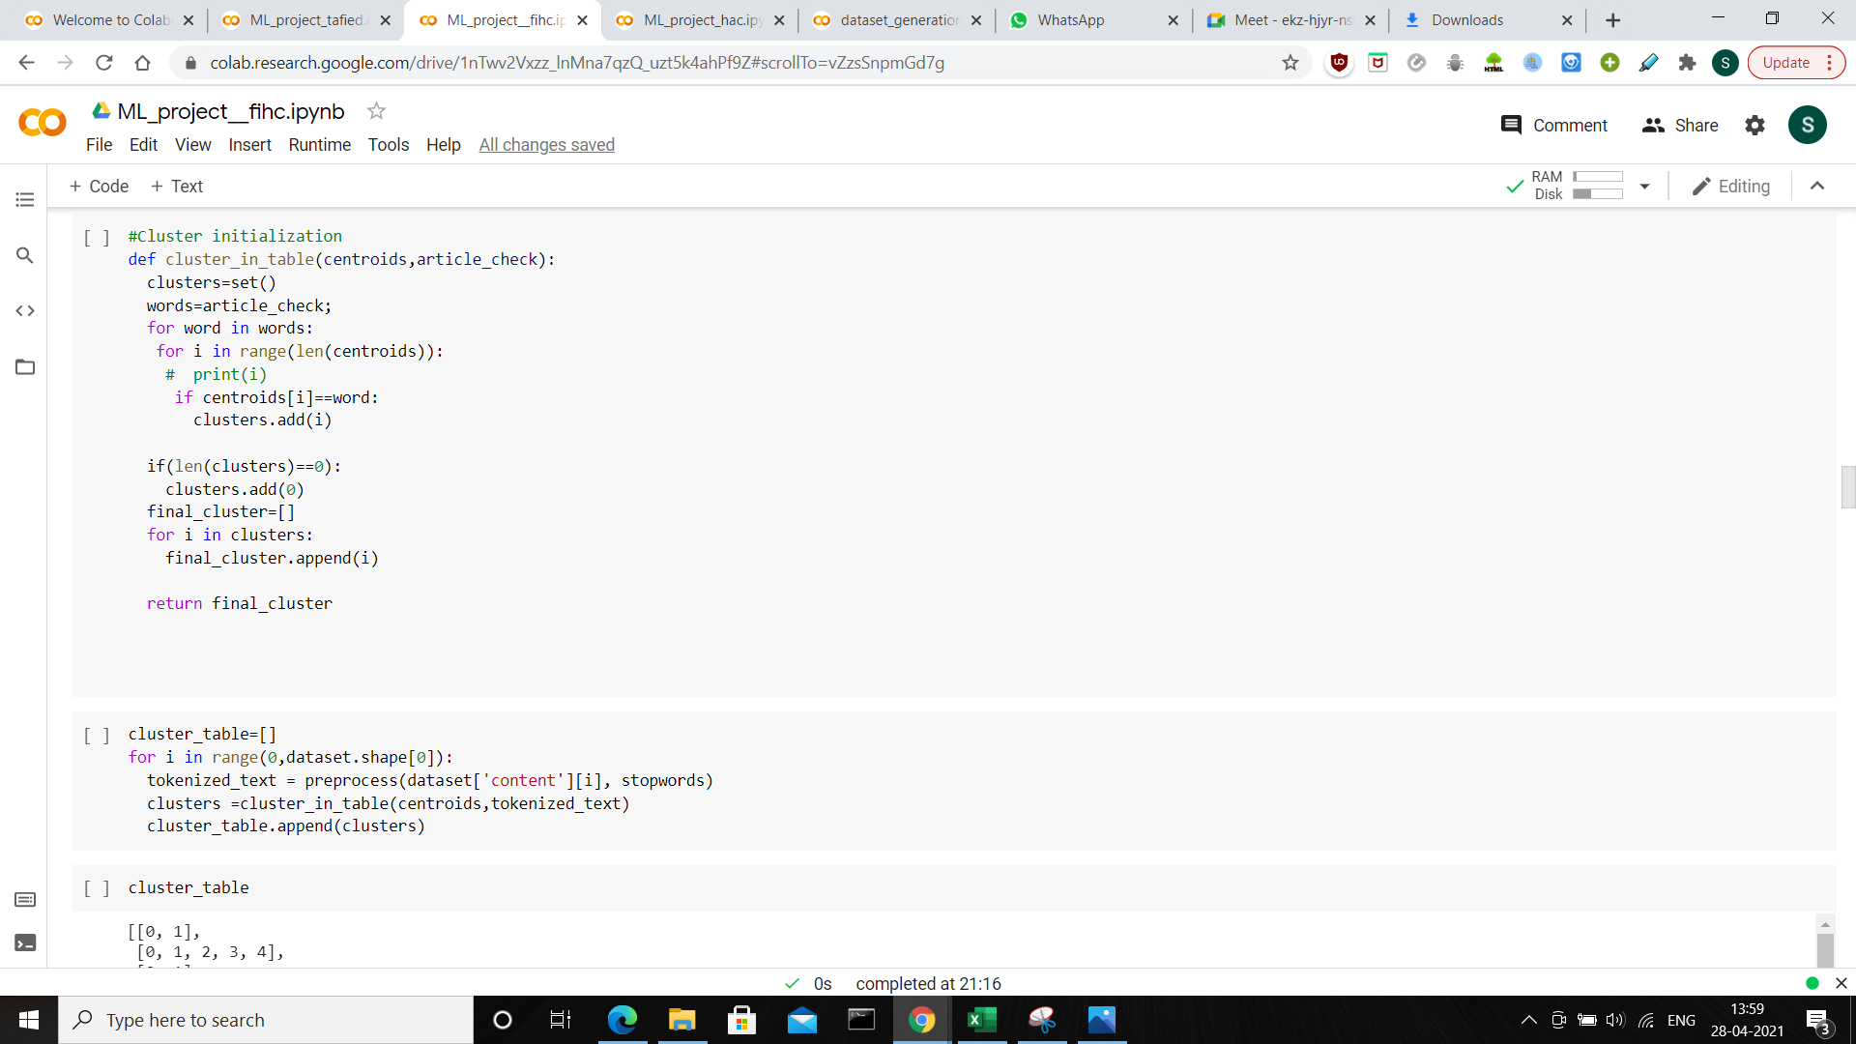

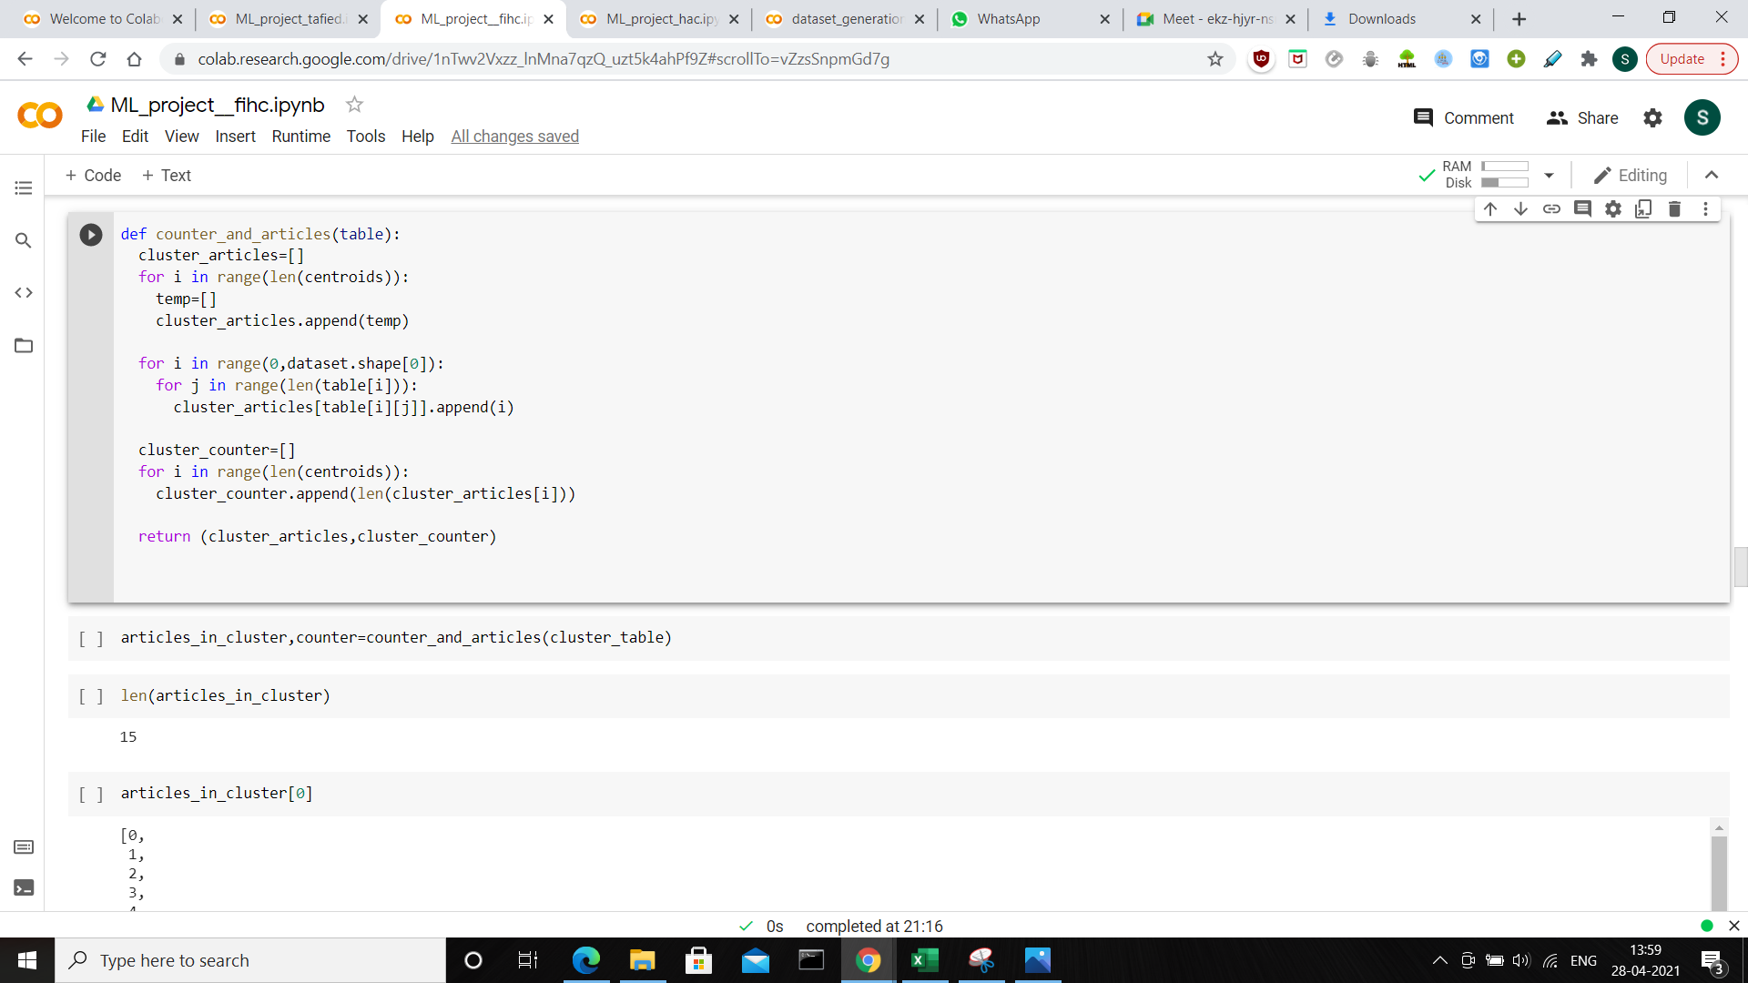

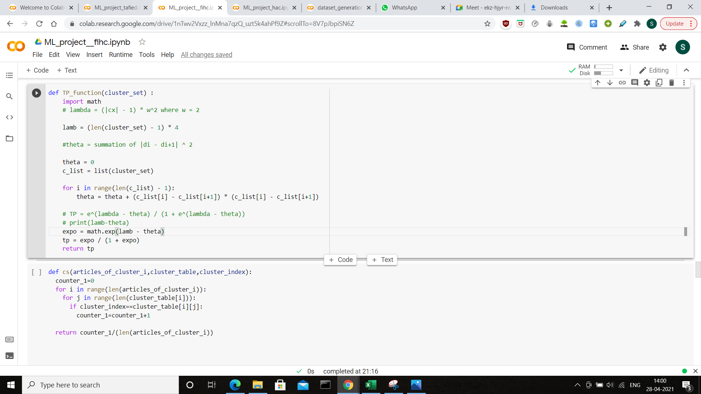

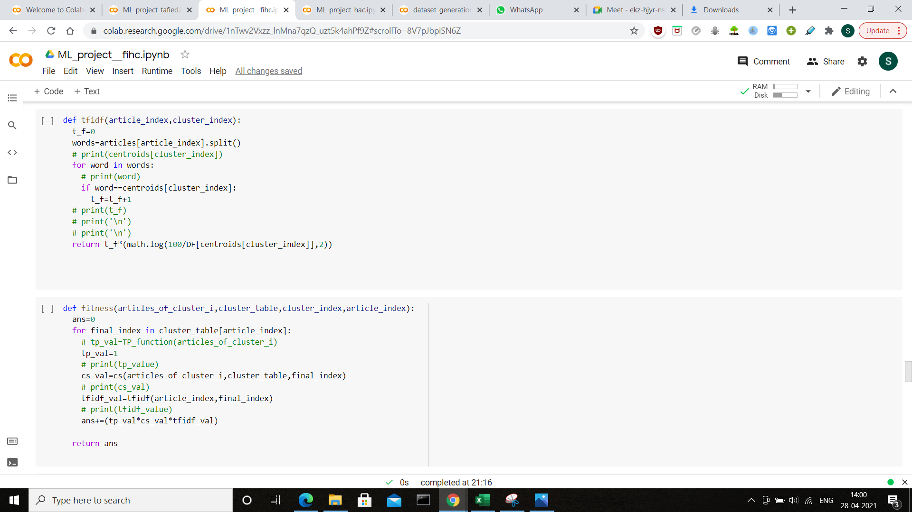

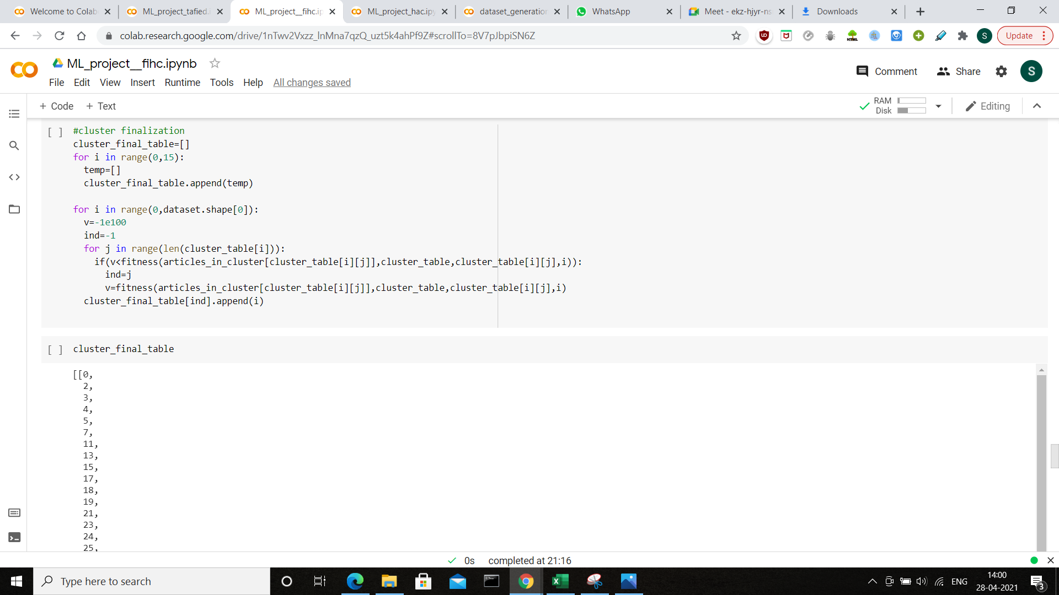

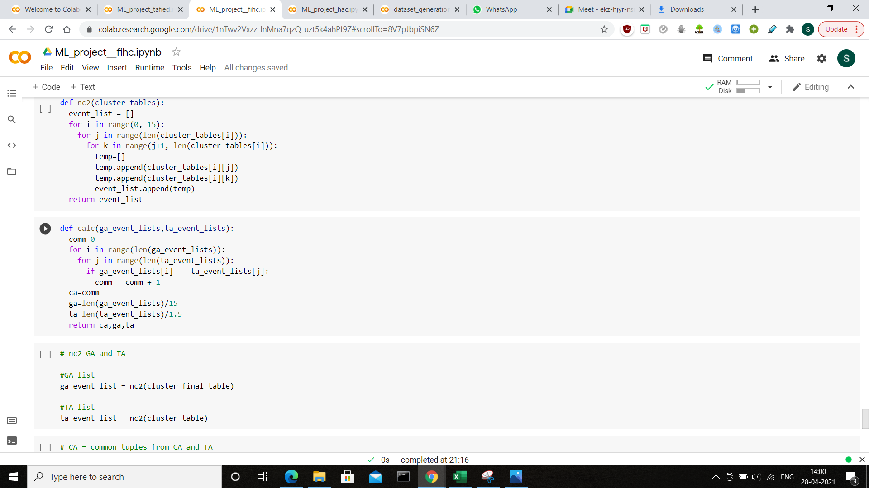

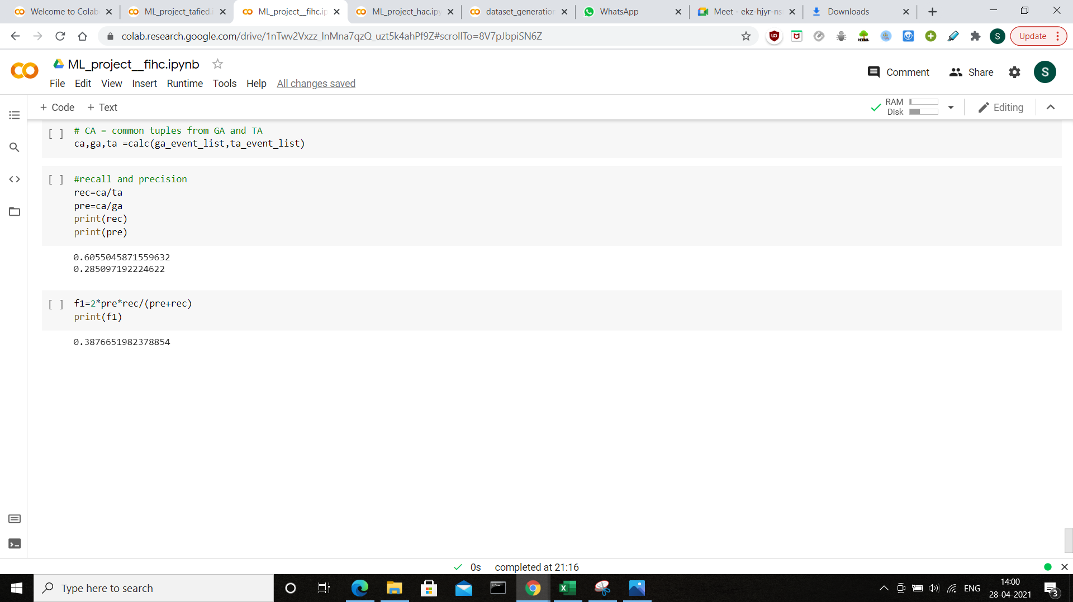

1. **Result Comparison**

|  |  |  |  |
| --- | --- | --- | --- |
|  | Cluster Recall | Cluster Precision | F-measure |
| TAFIED | 0.667 | 0.421 | 0.516 |
| FIHC | 0.606 | 0.285 | 0.388 |

1. **Future Scope**

Using API’s, web scraping the TAFIED algorithm can be run in real time making the process of maintaining the episodes of an event less cumbersome. The fitness function used in cluster distinction step has 4 more sub functions which are mathematically complex and take a lot of computational time. Thus this method may fail if the dataset is too large. A common efficient implementation of the algorithm which can overcome its current drawbacks.

1. **Improvements Done**

Due to the unavailability of the dataset given in the paper we created our own dataset using an Api. This enabled the dataset to become much more tailor made for our requirement as we could create it based on the events we specified. All the functions used in the TAFIED method were implemented in python without using libraries. HAC implementation for the same dataset has also been done.

1. **References**
2. [**Yen-Hsien Leea, Paul Jen-Hwa Hub , Hongquan Zhuc , Hsin-Wei Chend ,“Discovering event episodes from sequences of online news articles: A time adjoining frequent itemset-based clustering method “, 3 May 2019**](https://mail-attachment.googleusercontent.com/attachment/u/1/?ui=2&ik=185f448160&attid=0.1&permmsgid=msg-f:1694368002392929006&th=17839ab8956b32ee&view=att&disp=inline&realattid=f_kmbmcbaa0&sadnir=2&saddbat=ANGjdJ_5JME_RSl2VVvMELaCEY7jiRJAS4ZXm2dVY-BebEbg8XM58Kd3xtMBrDSYHO5PikrJ1aTPHvWkW1I4RCzqWA_-VFc9iB1-boGjcz1uYUdgynZpnaiRgWUtrHf1HHY04wiwROzUQV8Pj_h9EzR8E9PsYf-_L4c1hlDxpwio7pV_Ln5eDjOZItGXQUNFOhXJa3FjRVzrtRwuOnRVV2lhnz15aGueYVf0a7iPGBMHMfibzX4pZeJ9gHw_xHB__W33s5ZphengSTe_3XGzoe01YBGx5-tnPDGi-MF15DnlR-xLqt5jIKPl5Jn5f0RaK14wwbJNCRHophijpHtc7lvItMtL6yLLSnh8dFp3hYmCCNGUYhSTJ0c9SSWMv9GK6F15Z8Gw71kjOo53N9g3c-ffqJqGLAp2Zx0oVq9RAP_Jcj9t6pa6Y-J-9tMTqcu7kJ3Uks8NCpUTrTp2NEdavYobntoyrLR98aKa1j4kPK5SIB3sIQfhw76DXzSZoGhrqX1RF4cP8ggAsPYM7Gzbs4met--wTM0uGq4b0eGRh-Ow9mPXEJM35ZNE7VEfmG1JxRSi_CJms4J8jv3fz4vEoKw7X_eUDUcvbeq87nXrxGGwu8R1dPQSv5PYIzyzbDdELmVw7pixq6cSkKgKz8qlflotFZtCFN5afouqZCjqtLnv7lf1ymECLm9edhS_FbA)
3. [**Ramesh Nallapati, Ao Feng, Fuchun Peng, James Allan, “Event Threading within News Topics”, 8 November 2004.**](https://nitkeduin.sharepoint.com/sites/GroupDiscoveringeventepisodesfromsequencesofonlinenewsarticl/Shared%20Documents/General/Event%20threading.pdf)
4. [**Scikit Documentation**](https://scikit-learn.org/0.21/documentation.html)
5. [**NewsApi documentation**](https://newsapi.org/docs)